Introduction:

According to the document provided, the American University of Beirut Medical Center (AUBMC) has been facing certain difficulties related to the management of its staff in regards of how transport demands are dealt with.

From the beginning of the article, when the man entered Arwa Bou Ali’s office, we can notice that some patients are just being kept aside waiting until their turn to be transferred comes. This can be due to three main problems: is it because the porters are slacking during job hours? Is it because of mismanagement of porter staff? Or is it simply because that was a particularly busy day for the hospital?
Reading the rest of the article, we can see that the AUBMC is the only hospital in the Middle East to have earned three different and international accreditations, which make it one of the few institutions that should have a near perfect patient management. Yet, as one can imagine, accreditations are only words on a piece of paper, and small slip ups quickly become big problems that are often hard to deal with. In our case, such slipups have led to many patients being stranded and waiting to get the care they have requested and paid for.

In this report, we will identify possible shortcomings from the different parties involved. We will be discussing the different methods for the AUBMC to move forward with the issues at hand, as well as assessing the change they would cause if implemented.
Should the AUB Medical Center engage in a full re-engineering of its Patient Transport (PT) processes? If so, how should AUBMC go about such a re-engineering? (Part 1)

AUBMC is recommended to do a process redesign due to the current results it is experiencing, slow response time and dissatisfied customers are a major concern which needs to be addressed. By reengineering the process, it allows AUBMC to break down the existing processes, scrutinize each sub-process and replace it with more efficient processes. In addition, seeing that the load will be much higher in five years it would be a good opportunity for AUBMC to lay a scalable and efficient foundations to accommodate the much higher demand without having to resort to another process reengineering after the launch of the new building.

A process redesign involves a step-by-step approach to the process at hand, thus we will present each step on its own.

Step 1: Reevaluating the purpose of the process
- The process’ purpose is to transport patients across the medical center with as little waiting time as possible. This increases perceived patient-centered care, quality, service excellence and operational efficiency, in line with the AUBMC goals set for the new center.
- After reviewing complaints, we noticed that the hospital staff was complaining about transport jobs going unattended, this leads us to another purpose, attend every transport request even if late. While this might not increase the perceived service excellence, this goal is aimed for the busy days.

- Another complaint came from the dissatisfaction of the porters regarding double booking which is decreasing the moral of the workers, thus creating potential conflicts. The new process should aim for keeping one booking reserved for one transporter only. This will help boost staff moral and set a better working atmosphere.

Step 2: Identifying Sub-optimal processes

Since the main process differs slightly between each department we will classify sub-optimal processes by department.

- General Issues
  - Floor clerk takes a clear message from the Registered nurse
    - Adds an extra layer between the nurse and the transporter leading to extra wait time. Limited to handling one request at a time and is at the mercy of being held up by his two other processes below, blocking the request until another one is processed.
  - Floor clerk fills the log sheet
    - Paper based log sheet requires time to input, can take more time due to complex names for example. Limits ability to execute another process until this is done.
  - Floor clerk informs transporter about bed number, name of patient and destination
    - Floor clerk is once again tied to this process and cannot execute something else. The transporter needs to visit the floor clerk to get this information, costing the porter valuable time that should be diverted to reducing patient transfer time.
- Emergency Department:
  - Order filled by patient or companion
    - Does not give a good first impression of the patient care and service excellence. What happens if patient comes alone and cannot lose time in order to place a transport order? If this is the first time a patient visits, how would their companions know that they have to personally place the order? This reliance on the patient might give a sensation of irresponsibility and this is not in line with the objectives set. In addition if response time is not up to the expectations of the patient he might order another transporter, thus leading to double bookings.
- OR & Outpatient Support Units:
  - Nurse hands over transport request to an orderly
    - While this is a direct line between the staff and the transport (case of OR), it can cause bottleneck issues described below.
  - An orderly was responsible for transporting, positioning, lifting, cleaning the accessories and assisting the clinical team when needed.
    - Too many tasks handled by an orderly especially when in OR because he also has to assure transportation. In case he is needed in assisting the clinical team and a transport requests comes in he will be unable to transport the patient thus increasing wait time on patient side until the orderly is available. Too many tasks are assigned to a single entity here.
- Radiology:
  - Radiographer called the orderlies’ call center once the radiology exam was completed and asked for patient to be transported.
    - While this frees up resources by not tying any orderly to one patient, it might lead to cases where a patient finishes his radiology exam quicker or latter than expected causing potential overlap of requests to the orderly.

Step 3: IT and Technology Capabilities
One of the main issue we noted was the reliance on obsolete methods of communication when it comes to contacting the transporters. We cannot hope to improve efficiency and communication time using paper log sheets and face-to-face information transmission and mission tasking. We must be able to communicate information to the transporters without having them come over and explain the task at hand. This will require investing in a hospital-wide WAN network with wireless capabilities which will allow transporters to contact and be contacted on the go. This is will also require giving each transporter a tablet where the application will reside. The Wi-Fi coverage is already present and it can be leveraged in order to connect the transporters together.

Step 4: Design the new process

Based on Step 2 we can now propose a new process flow for each unit that reflects the improvements that must be incorporated into the new prototype.
- General Issues
  - Old:
    - Floor clerk takes a clear message from the Registered nurse
    - Floor clerk fills the log sheet
    - Floor clerk informs transporter about bed number, name of patient and destination
  - New:
    - Registered nurse places a request for a free transporter on her computer.
    - Free transporters which have marked themselves as free after delivering a patient will get notified on their tablet along with all the patient’s info.
    - First transporter to accept the job goes to the patient, the job shows “In Process” then “Completed” when it is done.
This way will allow us to bypass the Floor clerk and automate all the processes directly. The system can also handle multiple requests in parallel and has no theoretical bottleneck based on a designed request/seconds throughput. Potential issues might be related to Wireless connection issues which will require heavy testing before being used on a daily basis.
- Emergency Department:
  - Old:
    - Order filled by patient or companion
  - New:
    - Order filled by a clerk in addition to automated machines.
    - Patient can install an application on his phone that only works at the hospital if transportation is needed.

This approach gives patients a familiar element they can identify with while at the same time providing optional self-service desks in order to order a transporter. This is similar to airlines’ check-in booth nowadays, most of them offer self-check in kiosks while keep the standard offices for those who are unfamiliar with the newer technology.

Presented below is a General Control Chart summarizes the overall changes
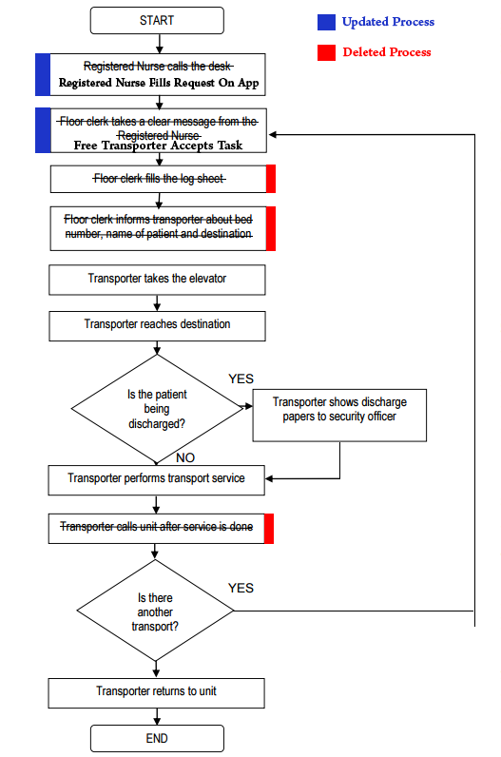

Key Performance Indicators: (PART 2)

If we are to take a look at the Key Performance Indicators, otherwise known as KPIs, there are several international benchmarked indicators that any healthcare institution should follow and abide by.

Relative to the case at hand, the AUBMC patient transport system can have the following KPIs:

1- Time until the transport order is processed: This will be a measure that takes into consideration the time between the moment a call is placed to the receptionist and the time that a porter is actually assigned to a patient.

2- Time until arrival of porter to patient room: This will be a measure of time in which we will see the amount of time lost between the assignment of a porter to a patient and the time that the porter actually arrives to the room using the different paths available in the facility.

3- Time until patient reaches his destination: This measure will be used to assess the different routes that the porters use in order to transport the patients. Are they using the most efficient route available for each order? or are they slacking and using longer routes?

4- Time to pick up patient and take him back to his room: As we know, a patient is never left lying around in the hospital, meaning that once the patient is done with the x-ray or any test he was supposed to do, the doctor at hand cannot leave him and just move on to another patient. This leads to the doctor at hand having to keep the next patient waiting until the porter comes and takes the first patient back to his room. Thus this will be a measure that shows whether time is lost waiting for a porter to come for the trip back to the room.

5- Time spent outside the room: All in all, once the patient is hospitalized, he has to spend the minimal amount of time outside of his room in order to minimize his exposure to alien diseases, prevent and complications and thus reduce his overall stay at the hospital. Thus, this will be a way to calculate the time that a patient spends outside of his room from the moment that the porter first comes to pick him up until he is sent back to his room.

6- Time spent on different porter orders: This will be a measure used to compare how much time is spent on each type of porter order. It will help make the transportation process more efficient by analyzing the different scenarios, and how time is wasted in each department.

7- Time spent per patient at the hospital: The more time the patient spends at the hospital, the more care he will need. Also, the longer the patient stays, the higher the chances of him being contaminated by something other than his original problem. Thus, it is more probable for a long-stay patient to require more than one test or intervention, and thus more transport orders. If we manage to isolate long-stay cases in a single ward, it would be useful to create a separate transport team that will be dedicated for such patients, and also better trained to deal with them.
8- Number of beds outside of their rooms: This KPI will inform the administration of the number of patients in transit at any given time during the day. It is important to know such details in order to manage porters properly and be able to direct them accordingly.

9- Urgent vs. Non-Urgent: This measure will indicate the urgency of a patient transfer. For example, a patient needing a transport of the operating room is considered more urgent than a patient going to take an X-ray. It is important to mention that the first patient is only more important due to the fact that operation slots are much more limited and time-oriented than an X-ray.

Potential solutions to the existing Patient Transport (PT) problem: (part 4)

After identifying some of the problems in PT, which are mainly: Miscommunication between staff members, doctors and the five teams of the Patient Transport (PT) unit results in double booking. In addition to miscommunication, there is an uneven workload and resource allocation among and within the decentralized five teams of the PT unit that can be seen in exhibit 2 and exhibit 3 in the case study (i.e. the number of employees in each shift does not always corresponds to the estimated workload distribution by shift). One more problem is Using only one of the four existing elevators for porters which is a constraint to complete the process of transporting the patients by waiting for the one available elevator for the ten floors. More problems will arise when there are an exceeded number of patients that need to be transported by the same elevator. All these problems will result in lower productivity, more wastes and longer process time. All of that will result in additional complaints. (Abdulhadi, 2015)

I suggest using some of the lean tools in process management developed from the Toyota Production system (TPS), which mainly focus on increasing value and eliminating waste.

Miscommunication results from lack of information, slow information transactions or from misinterpreted information. One of the lean solutions is to use visual control so no problems are hidden (Liker, 2004). For example, all team members involved in PT can have a small electrical device managed by a central unit that will inform them when they are needed to perform a specific task. In addition, the electrical device can help identify the bed number and floor where the transporter needs to transfer a patient. In this way the process is more visual and information can be transformed instantaneously. By eliminating the root cause of miscommunication, we eliminated a non-value adding step to the process hence eliminating one source of waste. This will increase the productivity of the staff to handle patient transportation more efficiently and more effectively.
There is an uneven workload and resource allocation between each team member of the PT. Furthermore, the number of porters for each shift is not evenly distributed for the estimated workload distribution represented in exhibit 2 (Daouk-Öyry, Lina et al., 2015). In addition, as shown in exhibit 3, the number of employees and the resources needed does not confirm with the locations and the areas covered for each unit. This unevenness in the process will result in overburden of the staff. This will result in decreasing staff productivity, leading to a longer process time. A redistribution of both the employees and the resources allocated for each team is required to ensure that the workload is distributed evenly among the teams and the areas to be covered. This application will eliminate unevenness and overburden which according to the TPS are two kinds of wastes. The redistribution should be based on proper forecasting to predict the number of patients on a monthly basis to properly and evenly balance the employees and resources within each team of PT unit. Another problem is the availability of only one elevator of the existing four to be used for transporting patients. This resembles a bottleneck in the process that will slower the whole process time. Situations will get even more complicated when there is pressure on the usage of this elevator. A solution for this problem would be to allocate another elevator to be used by the PT unit whether it was using another existing elevator or constructing a new elevator.

Ohno’s 7 Types of Waste: Defects in products , Overproduction of goods not needed, Inventories of goods awaiting processing or consumption (work waiting on workers), Unnecessary processing, Unnecessary movement of people, Unnecessary transport of goods, Waiting by employees for process equipment to finish work or for an upstream activity to complete. (Workers waiting on work) (Liker, 2004)

